1. The sorting feature is not functioning for any column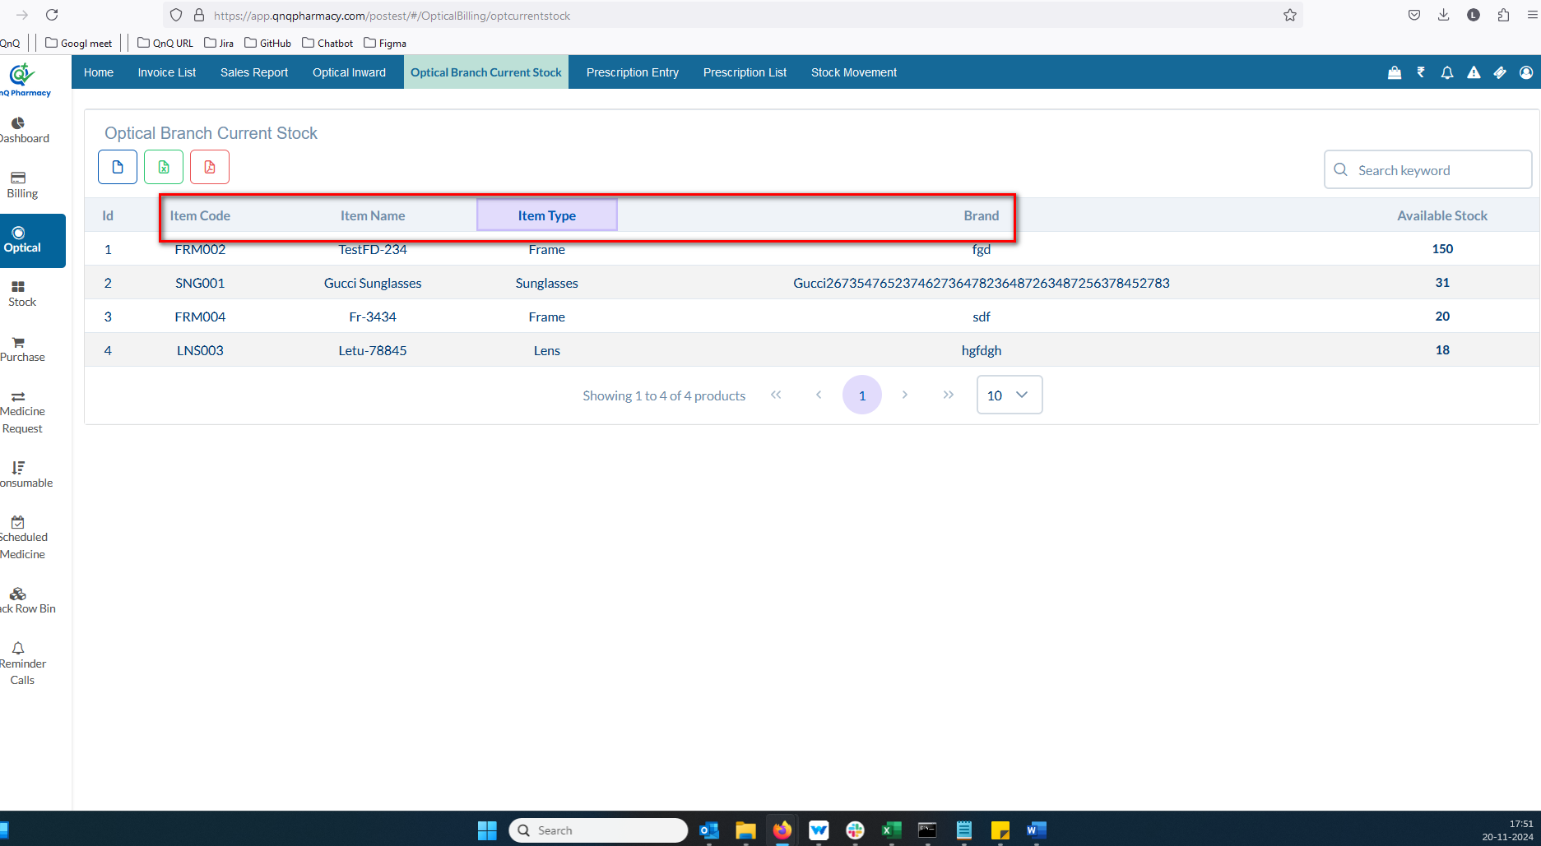//
2. The column separation line/border is not visible in the Inward list grid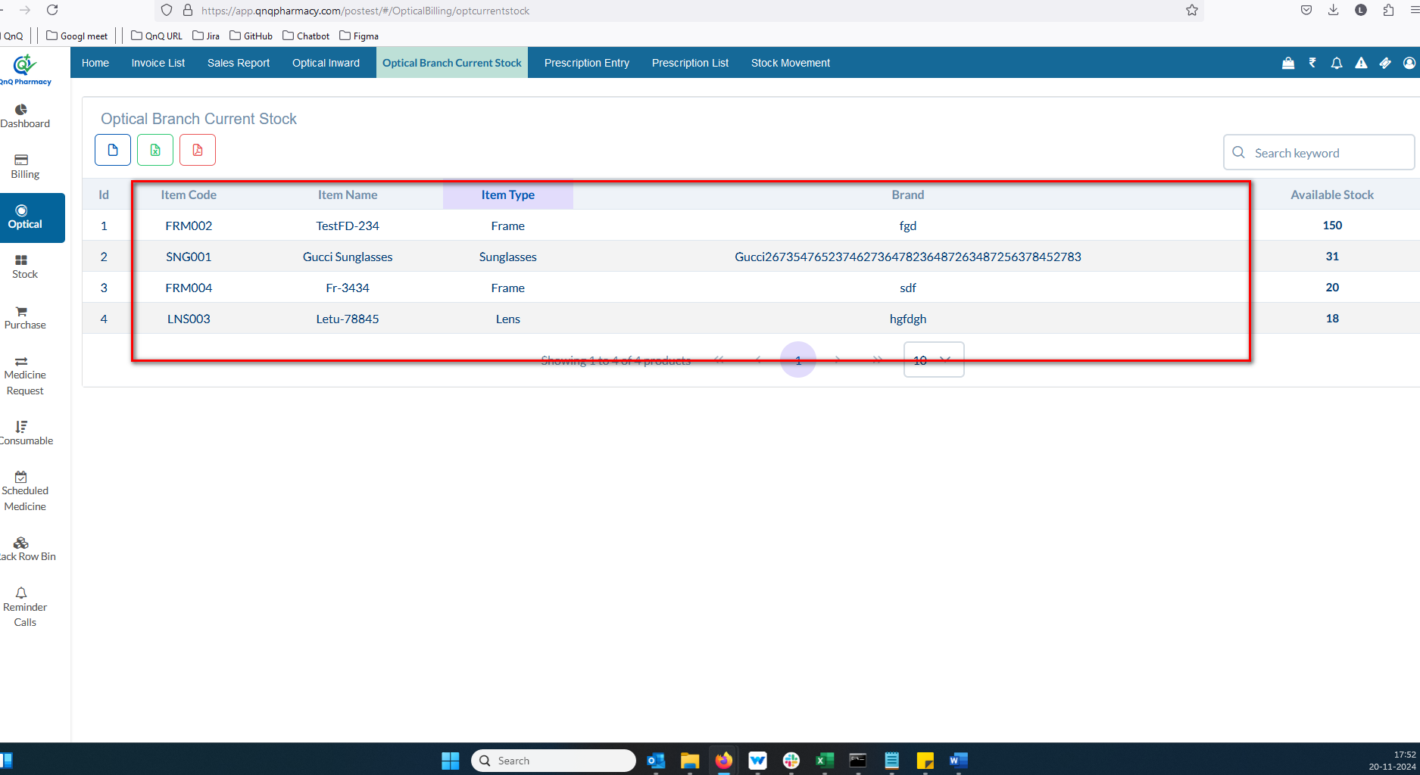 //
3. No record available message not display in list grid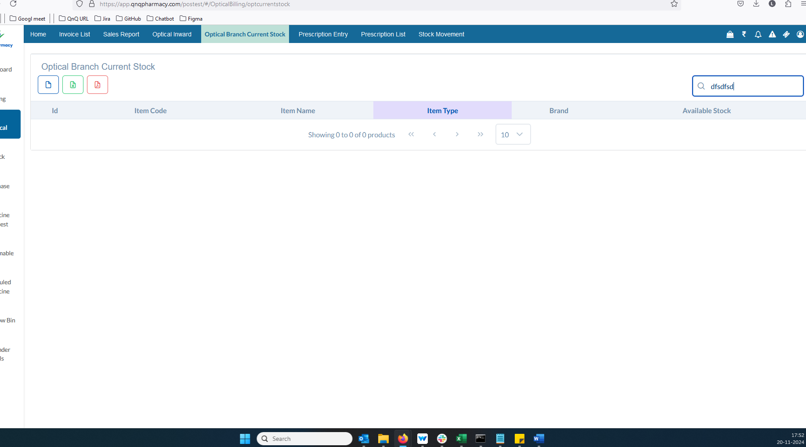//
4. The pagination controls and count dropdown are positioned in the center of the page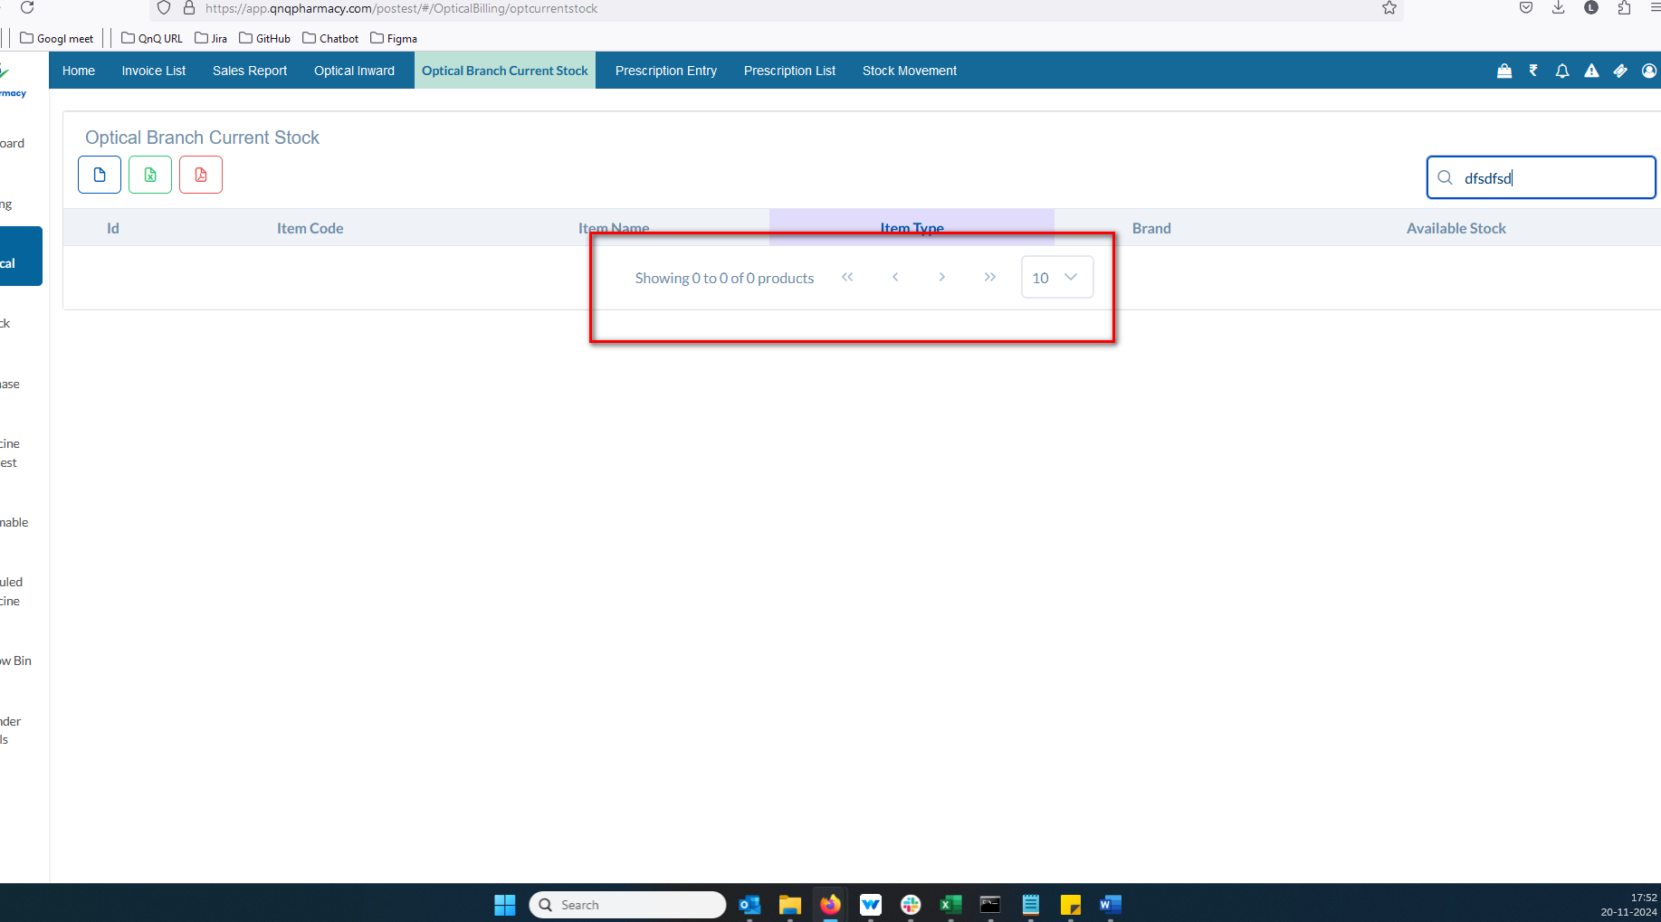//
5. Mismatch column name display in list grid 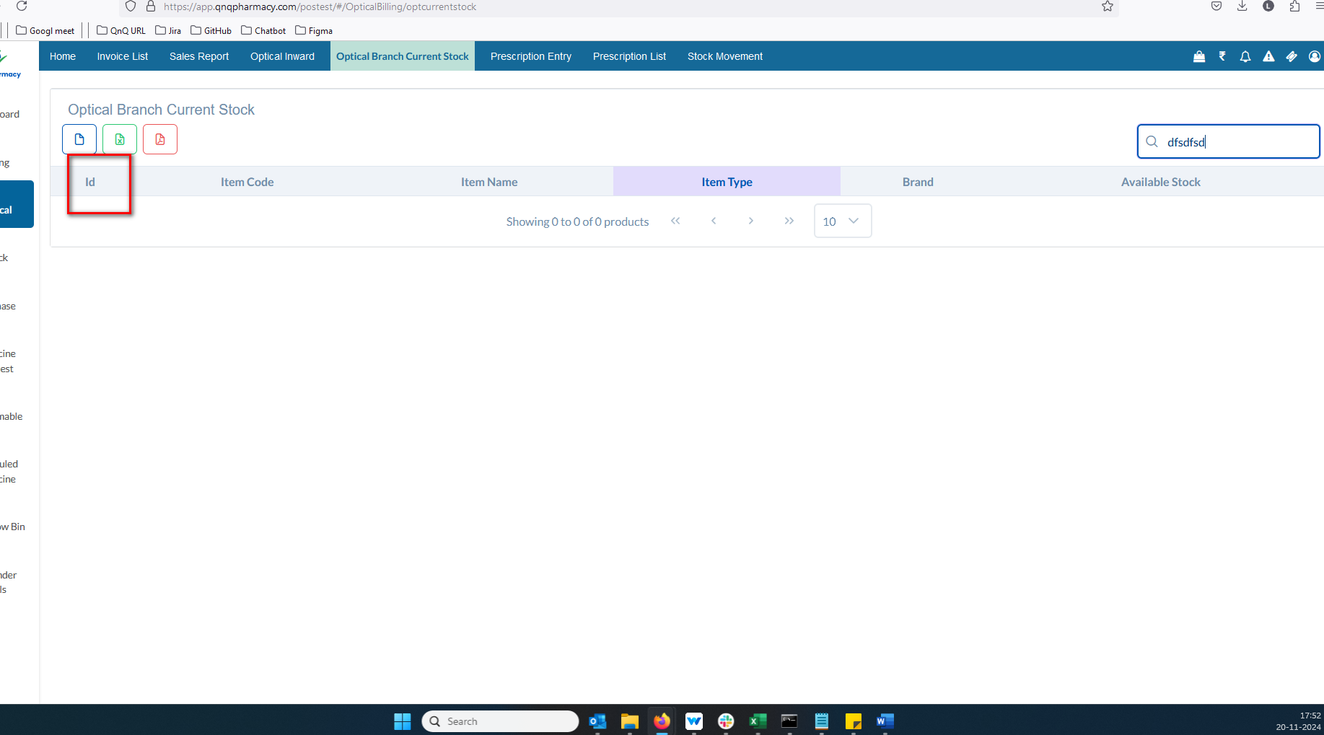//
6. Unwanted colour display while click column header 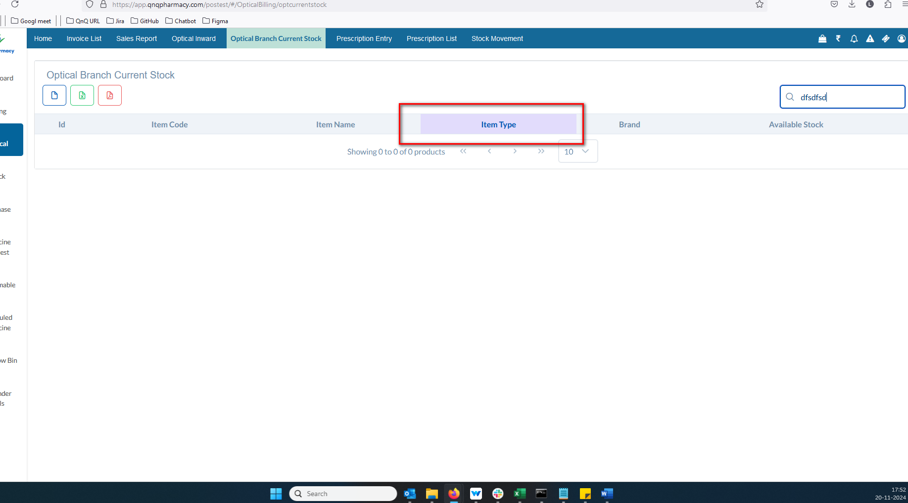//
7. Sort icon not display in list column 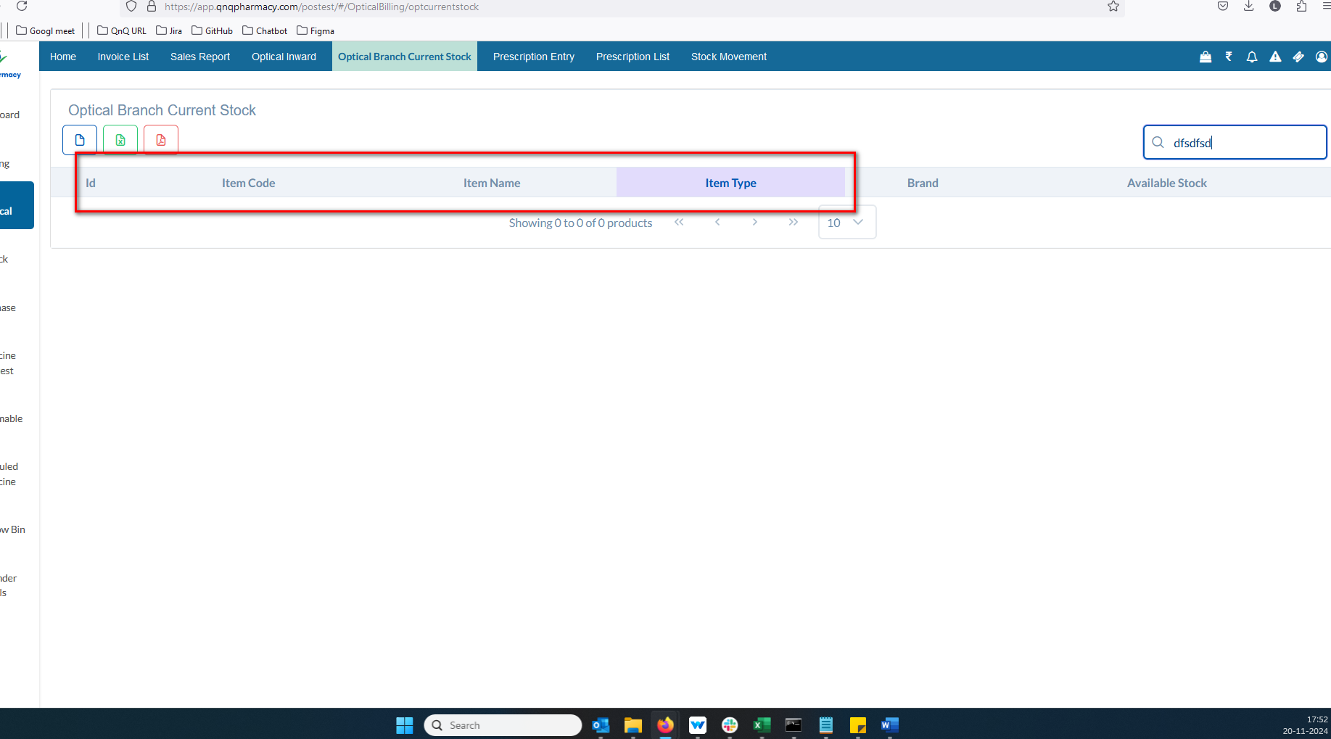//
8. Improper alignment display in list grid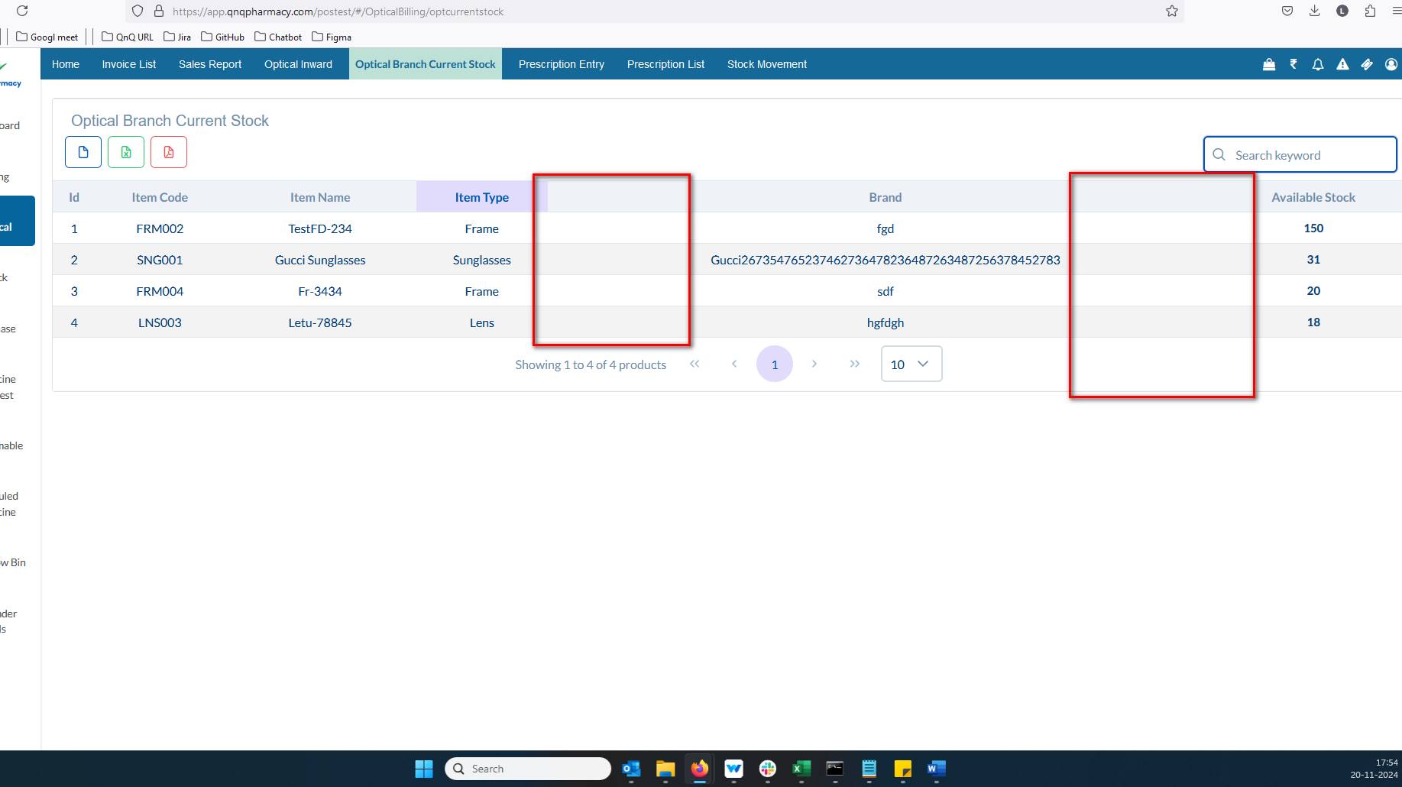//
9. Mismatch File name display in the CSV file 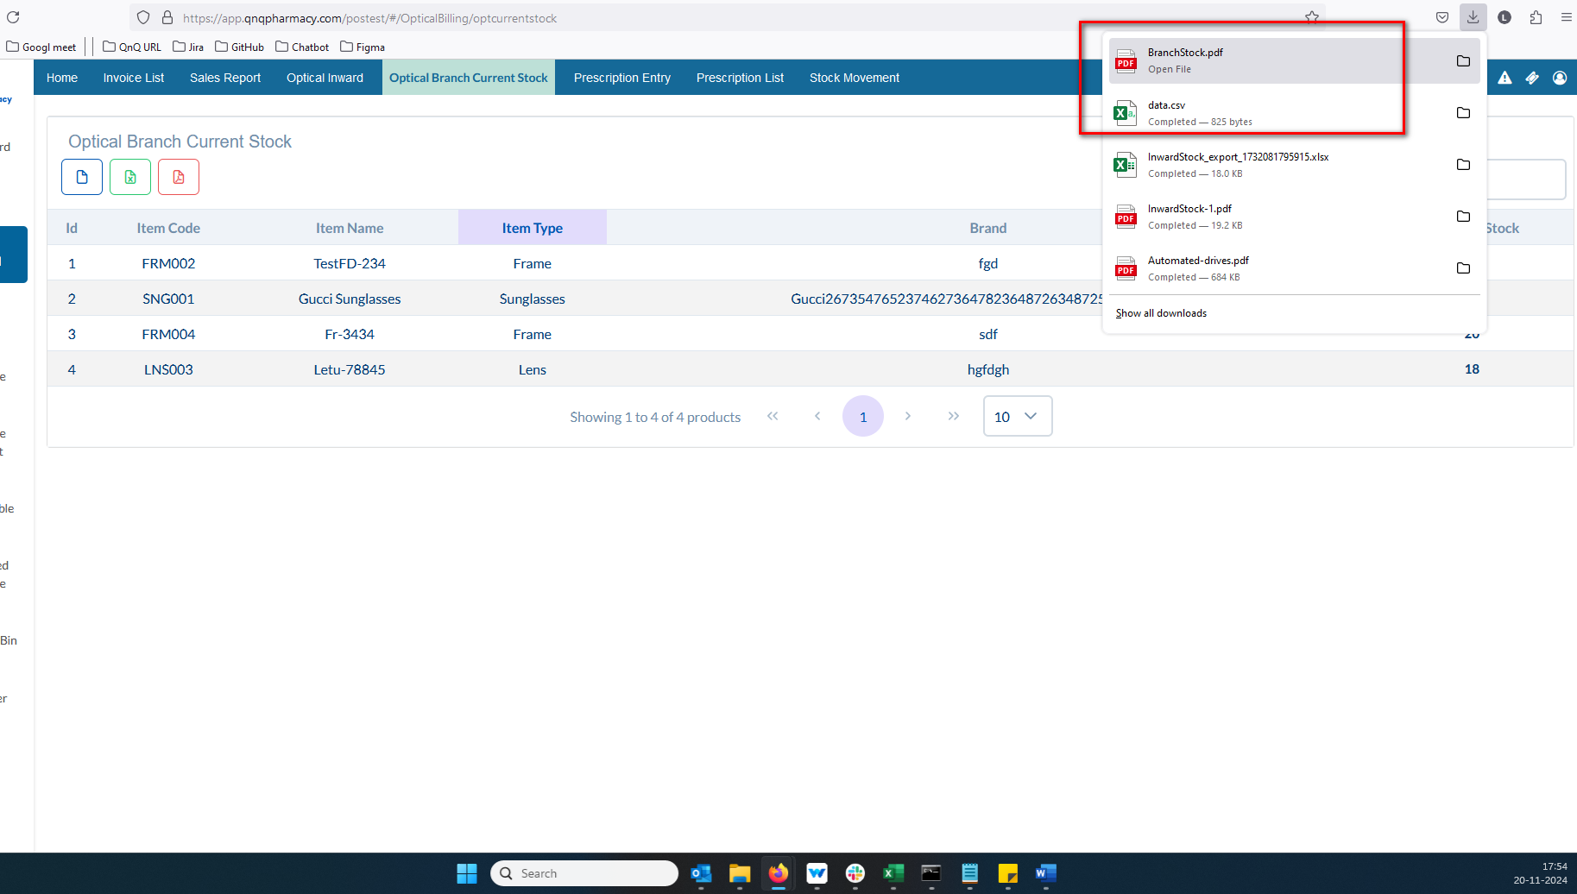//
10. Mismatch Sheet name display in all downloaded document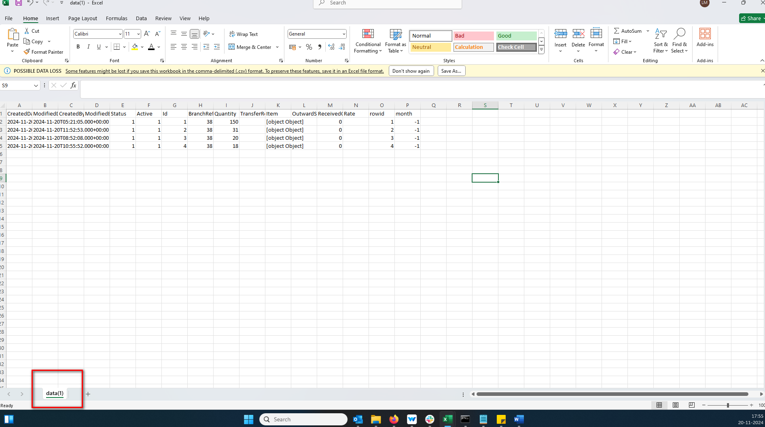//
11. The column header does not appear like the ad header column in CSV file 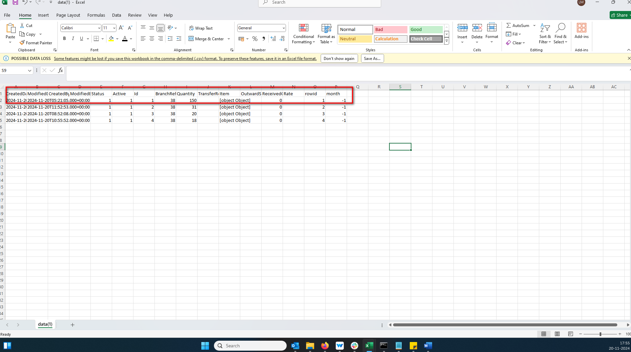//
12. The CSV download option displays an incorrect icon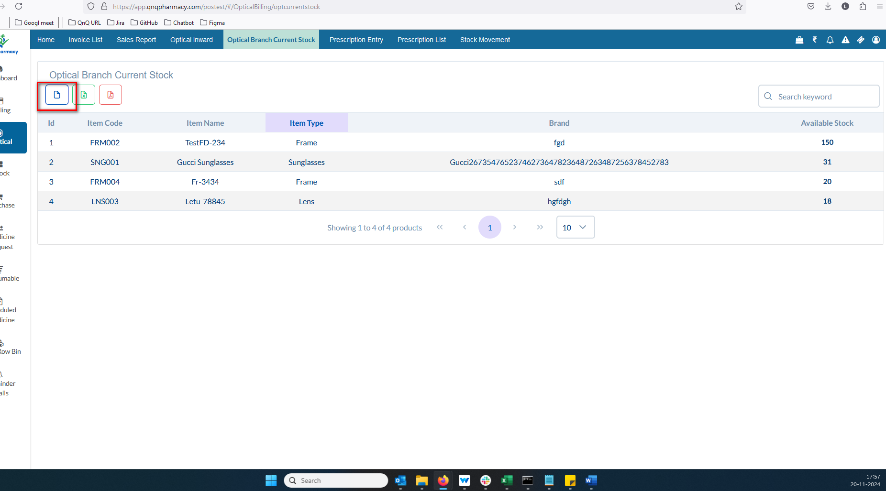 //
13. Download options are displayed even when no values are available in the list grid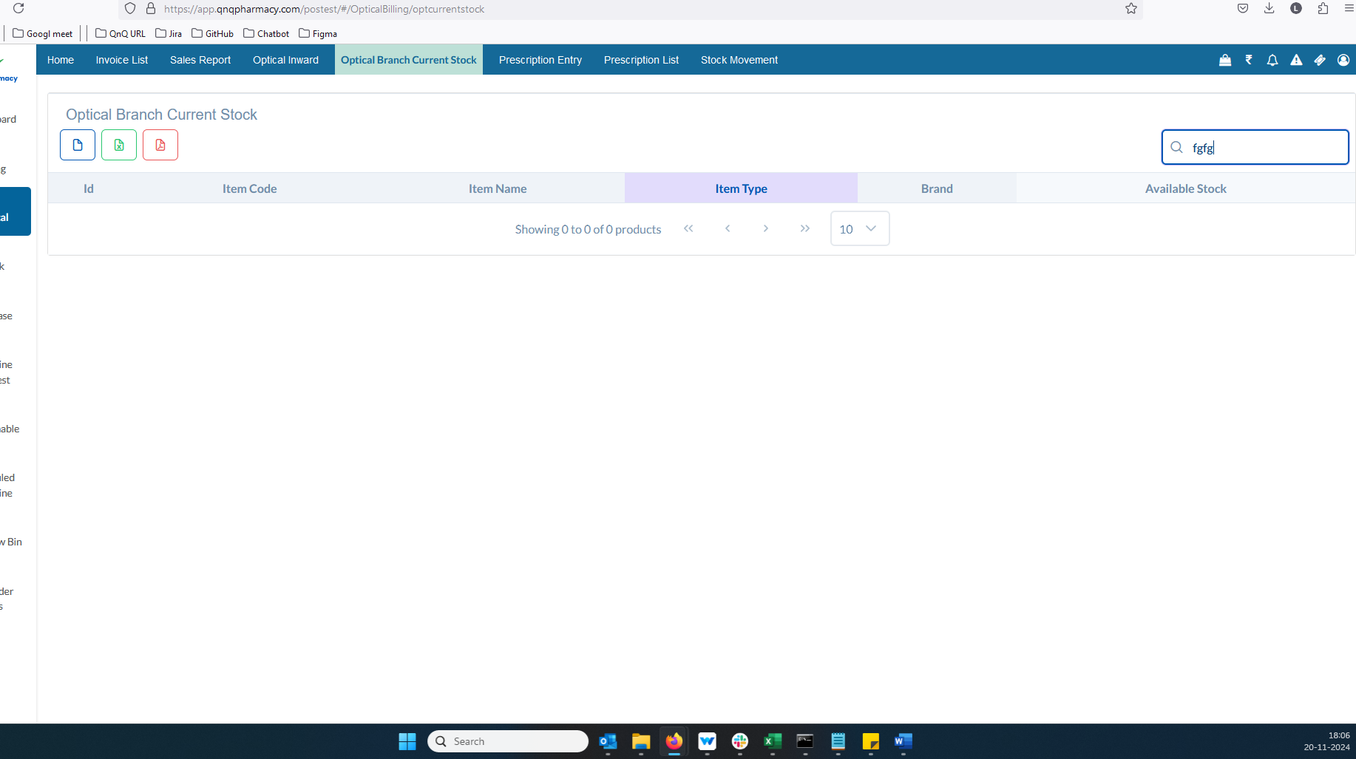 //
14. The list grid presents one type of data, while the downloaded document shows another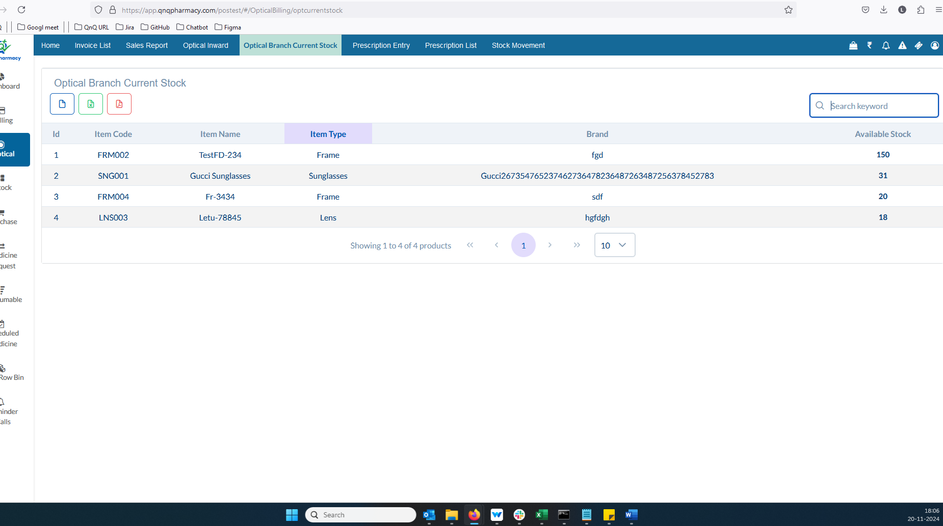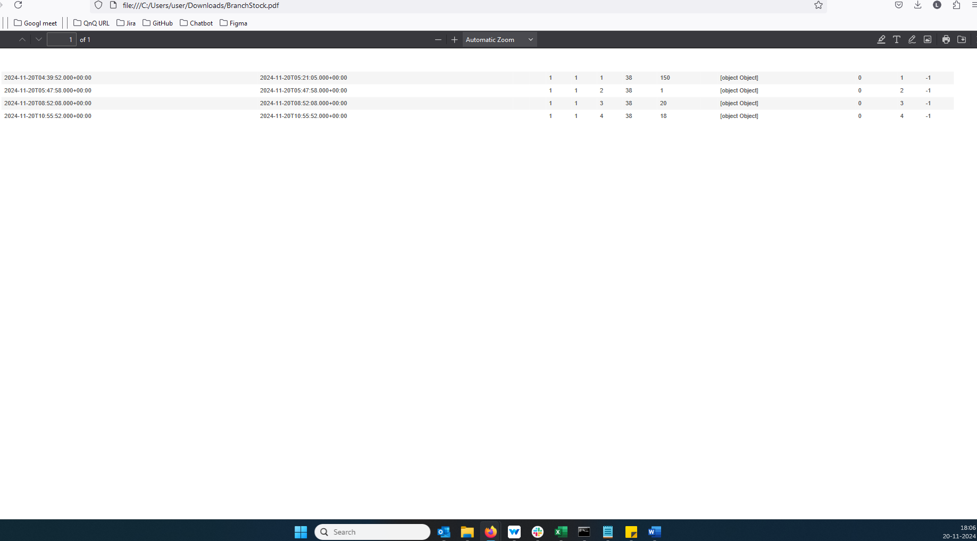//
15. //
16. //
17. //
18. //